Practical 5
Question:
Write a C program to demonstrate inter-process communication using a pipe. Create a pipe and two child processes, where the first child executes the ls -l command and redirects its output into the pipe, and the second child reads the data from the pipe and displays the result.
Code:
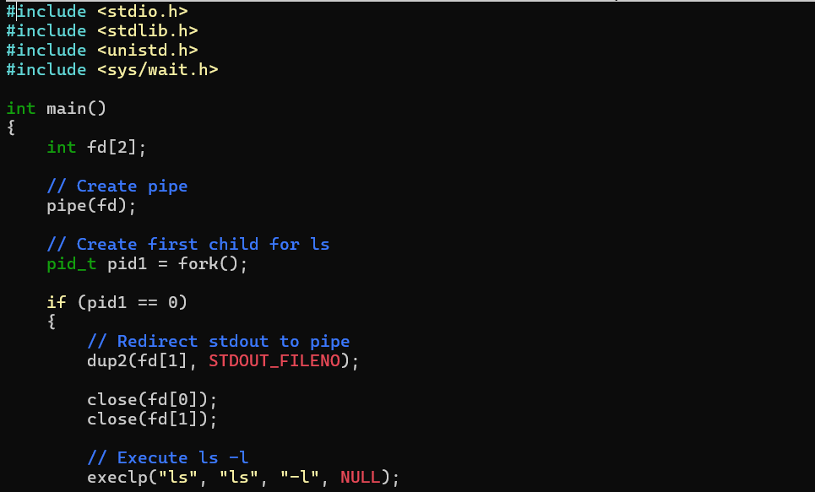
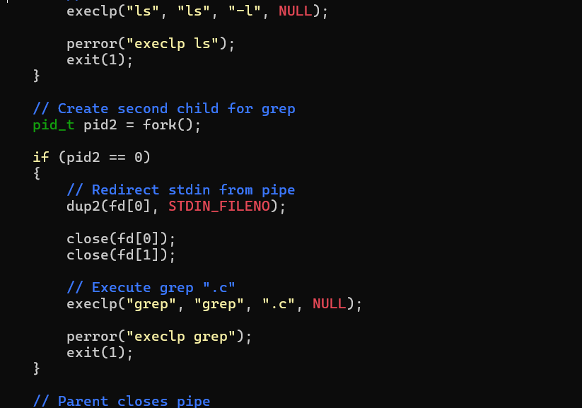
Output:
